TalkReserve

## Elevator Pitch

Create an application that will serve as a reservation order form. Associates of the Church Store will quickly receive order’s from church members by inputting order request. This will improve customer service and provide a quick process to process product reservations.

## The TalkReserve MVP features:

* Allow store associate to place reservation order for member
* Show calendar schedule
* Allow store associate to log in
  + via social media
* Feature the two recent sermons

## MVP Stories

#### Allow store associate to place reservation order for member

* + Create 2 drop down selections.
  + From drop down selections add to textboxarea
  + Email textboxarea selections to admin
  + CRUD on reservation form
    - Able to delete from create textboxarea, read from textboxare, update textboxarea, delete from textboxarea
    - Add review via social media

#### Show calendar schedule

* Create Calendar that will show on account page
  + Calendar will show who is working in the customer service
  + Use Angular Calendar or UPTO plugin Calendar

#### Allow store associate to log in

* Customer service and store associates will log in
  + Sign in by log in and email
    - Set up log in and email through Firebase
  + Sign in by Facebook
    - Set up log in and email through Firebase and Facebook

#### Feature the two recent sermons

* Feature the two most recent sermons on homepage

## Technologies

* Angular, AngularRoute, AngularResource, Anuglar Cookies, Firebase, GRUNT, Javascript, Jquery, Bootstrap, MongoDB, Mandril

## Wireframes

Home Page

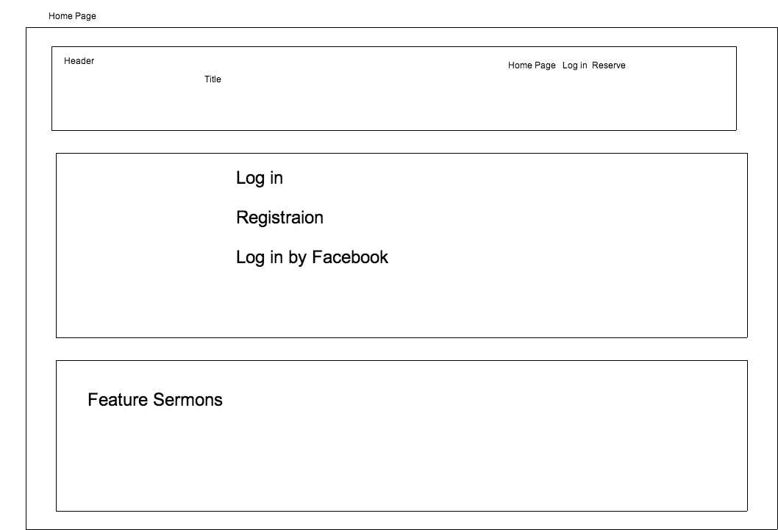

Account Calendar

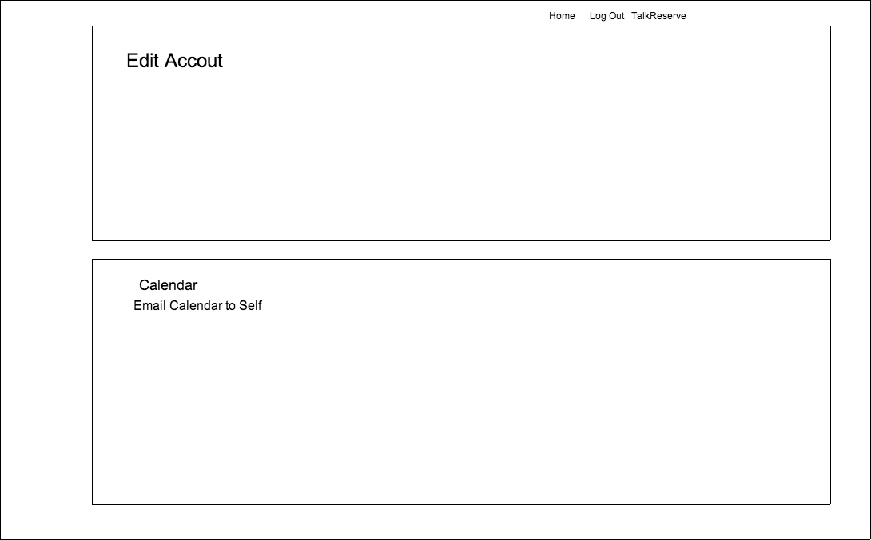

TalkReserve Page

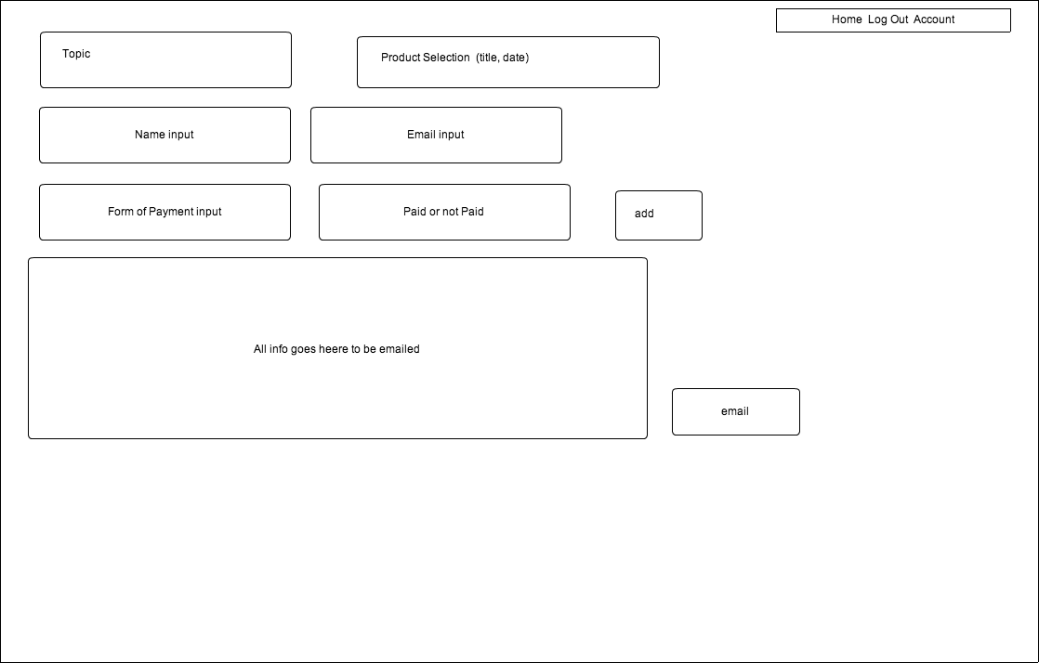

## User Story Template

* Ability to CRUD product reservations
* View calendar schedule
* Login
* View recent sermon

## Acceptance Criterion

* Store associate is able to create reservation
* Store associate is able to update reservation
* Store associate is able to delete reservation
* Store associate is able to read reservation
* Store associate can view the feature sermon
* Store associate can log in

### Notes

Fill as I go….